1. HomeScreen of YourPrice Ecommerce Application with logo, name and slogan

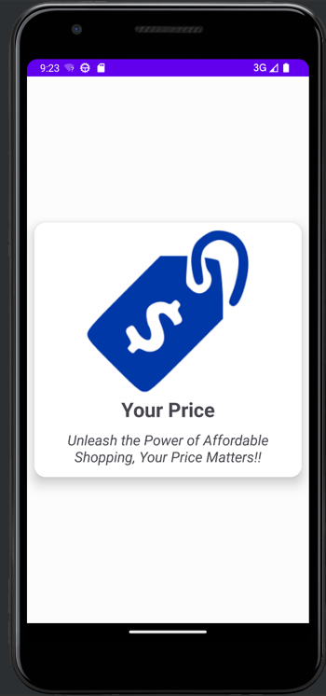

1. Scrollable list of products(phones) in CardView containing image, brandname, price and description

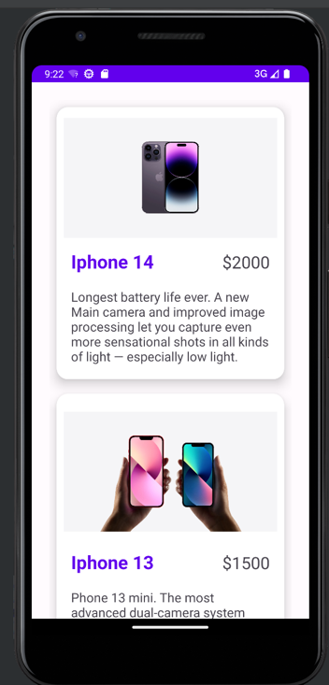

1. Checkout Form

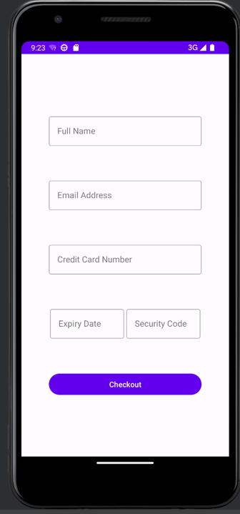

1. Checkout form with expiry date input clicked

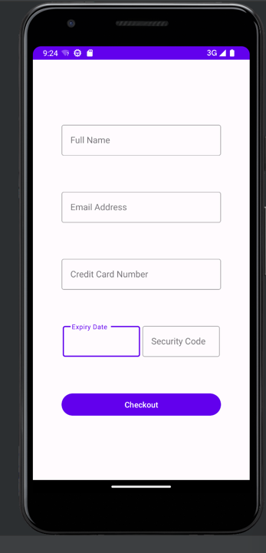

1. Landscape mode homeScreen

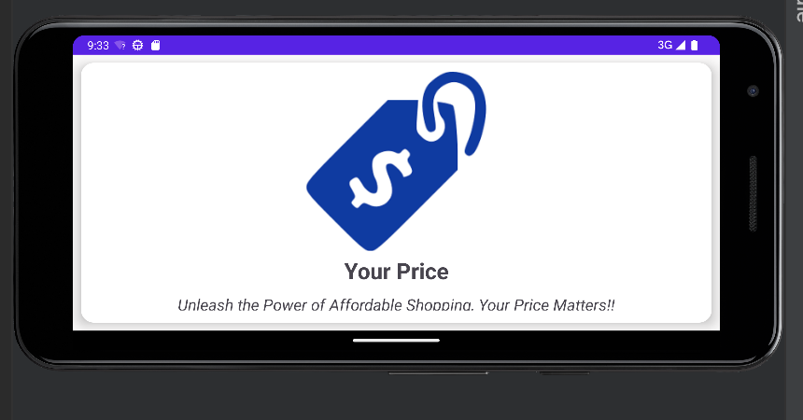

1. Product list in landscape

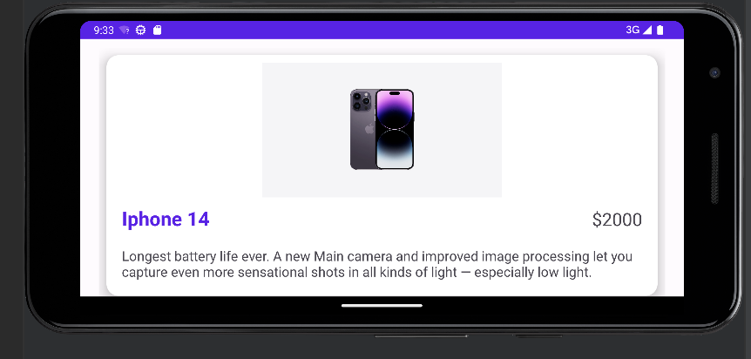

1. Checkout form in Landscape

